SIMPLE STEP
One of the first things that I made for my boat was a step to go in the hatchway. I quickly did away with the table fitted to the king post as it seemed to get in the way and this step seems to provide a good alternative.
It is made from some oak that I had lying around; I think it came from an old desk or drawing board thrown out from work.
Very basic construction just glued and screwed together. It has proved useful as a step/seat/table/chopping board/bench etc. It is not fixed in place so can be moved or removed as needed.
Dimensions can vary but it should be thick enough to take your weight without flexing.
As they say a picture paints a thousand words:
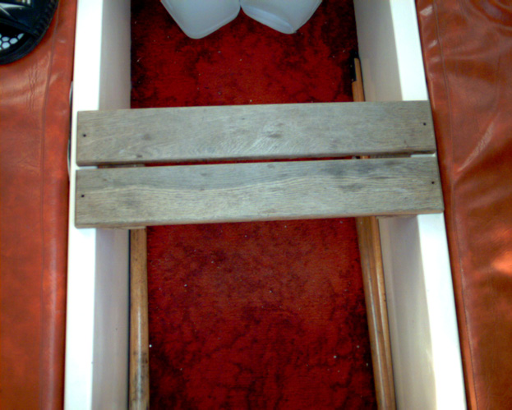
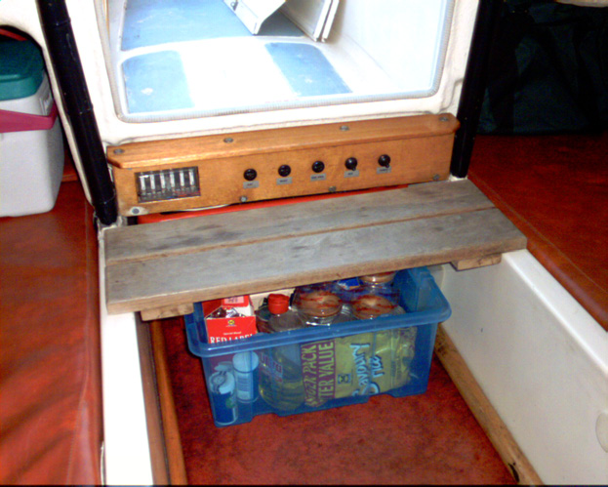
Dave Smith ‘Mischief’ (S17 350)

